Sounds and Transcription

Surprise - /səˈpraɪz/ or [səˈpraɪz]

Park - / pa:k/ -

/a : / - the long vowel marker

Stress

primary stress - /səˈpraɪz/

secondary stress - /ˌriːˈtel/

Vowels
Short

/ɪ/ | /ʊ/  /u/ | /ʌ/ | /ɒ/  /ɔ/ | /ə/ | /e/ | /æ/

Long

/iː/ | /uː/ | /ɑː/ | /ɔː/ | /ɜː/

Diphthongs

/ɪə/ | /ʊə/ | /aɪ/ | /ɔɪ/ | /əʊ/ | /eə/ | /aʊ/ | /eɪ/

Consonants
Voiceless

/p/ | /t/ | /ʧ/ | /k/ | /f/ | /θ/ | /s/ | /ʃ/

Voiced

/b/ | /d/ | /ʤ/ | /g/ | /v/ | /ð/ | /z/ | /ʒ/

/m/ | /n/ | /ŋ/ | /h/ | /l/ | /r/ | /w/ | /j/

READING PRACTICE

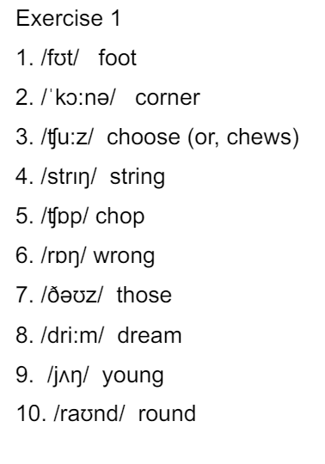 | 