Пахайло Юлия Леонидовна
учитель английского языка
МАОУ СОШ №4 им. В.В. Самсонкиной
ст. Кущевская, Краснодарский край

Comparative quiz
для 6 класса
Put the words in the correct order and write sentences with the superlative and comparative
Big  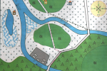 | city /village/town | Example:  1. City, town, village  2. A city is the biggest.  3. A town is bigger than a village.
Deep | puddle/river/stream
Fast  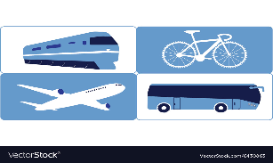 | train/plane/bicycle
Young | baby/teenager/child
Popular | theatre/TV/cinema
High | tower/building/skyscraper
Large | sea/ocean/lake
Sweet | tea/coffee/juice
Expensive  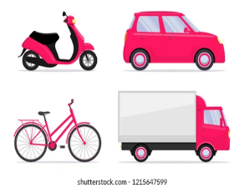 | bike/car/scooter
Important | captain/sergeant/ major | Example:  1. Major, captain, sergeant  2. Major is the most important.  3. Captain is more important than sergeant.

