Christmas Lesson Procedure:

Warm Up and Maintenance:
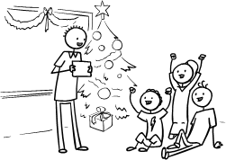1. Start the lesson as you usually would (E.g. Hello song, "What's your name?", "How are you?", homework check, etc.).
2. Show a flashcard picture of Santa. Elicit who it is ("Who is this?"). Explain that today and next class we are going to have a Christmas Lesson. Put on some Christmas carol background music to create a Christmas atmosphere.
* For older / higher level kids, here you can discuss what they want for Christmas. Teacher start by modeling "For Christmas I would like (a bike)".

New Learning and Practice:
1. Teach new vocab: Santa (G.B. Father Christmas), Rudolph, sleigh, presents, Christmas tree, decorations, roast turkey, Christmas pudding:
Use flashcards or pictures. Hold up each picture and chorus x3.
2. Play "Flashcard Touch" and "Missing Flashcard":
Flashcard Touch: Lay the flashcards out on the floor. Tell the students to put their hands in the air. Then Teacher calls out a flashcard (e.g. "Christmas Tree!"). Students have to touch the card as quickly as they can. Play for a few rounds until you have done all of the flashcards.
Missing Flashcard: Tell the students to close their eyes. Take away a flashcard and tell the students to open their eyes again. Ask "Which picture is missing?". Students have to shout out the missing flashcard. Play a few rounds.
Note: For larger groups, divide your students into groups of 6-8 and play the games in their groups.
3. Teach song "We Wish You A Merry Christmas":
Most Christmas carols use a lot of difficult vocab or vocab which isn't used in modern English anymore. This doesn't make it easy for teaching lower-level English learners! However, we can adapt songs to fit the vocab you are teaching. In this case, we have adapted the carol "We Wish You A Merry Christmas" (download MP3 at the end of this page).
The following adapted lyrics are used with the song:
"We Wish You A Merry Christmas"
Chorus:
We wish you a Merry Christmas,
We wish you a Merry Christmas,
We wish you a Merry Christmas,
And a Happy New Year.
Verse 1:
Santa and Rudolph,
Will fly in their sleigh,
We'll open our presents,
And have a great day!
Chorus
Verse 2:
Our Christmas tree's up,
With decorations,
We'll eat a roast turkey,
And Christmas pudding.
Chorus
Verse 1 again
Chorus
Verse 2 again
Before playing the song, line up the flashcards on the floor or the board. Then, play the song and Teacher sings and touches each flashcard as the vocab word is sung, to show everyone how the song goes. Encourage the students to join in. It may be worthwhile slowly running through the song without the music first.
Then everyone sings the song together.
We also have a video that you can stream in class to sing along with (Internet connection required):
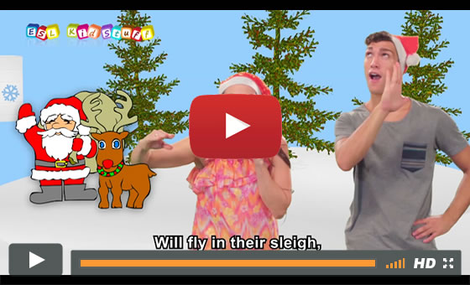
NOTE: We also have an adapted version of the carol "Jingle Bells" which you may want to use instead of or as well as "We Wish You A Merry Christmas". You can download this at the end of this page.
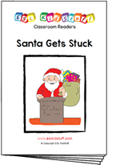4. Read classroom reader "Santa Gets Stuck"
This classroom readers ties in perfectly with the We Wish You A Merry Christmas song above as it uses many of the same phrases and vocabulary. Before class, download and print off the reader "Santa Gets Stuck". As you go through each page, point to the pictures and let your students shout out what they can see and think is happening:
Teacher: Who is this? (pointing at Santa and Rudolph on page 1)
Students: Santa and Rudolph!
Teacher: Yes, that's right! (reading from the story) " It’s Christmas Eve night. Santa and Rudolph are flying in their sleigh." What color are Santa's clothes?
Students: Red!
Teacher: That's right. Santa always wears red. (turning the page) ... Oh look! What is this boy doing?
Students: He's sleeping!
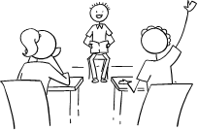Teacher: Yes, that's right! Look, how many stockings does he have?
Students: 2!
Teacher: Yes, 2! He has 2 stockings for his presents from Santa.
etc.
Get the students really involved in the story by asking lots of questions (e.g. eliciting the objects and their colors) and even getting everyone to speculate about what presents the boy and girl have under the wrapping paper.
There is also a reader worksheet to use with the story. For lower level students (level Starter), have them put the numbers on their worksheets as you read through the story. Students reading the Level 1 reader can try to complete the worksheet in pairs after reading the story. Then go through the answers as a class.
---
Alternatively, watch our video version of the reader (Internet connection required):
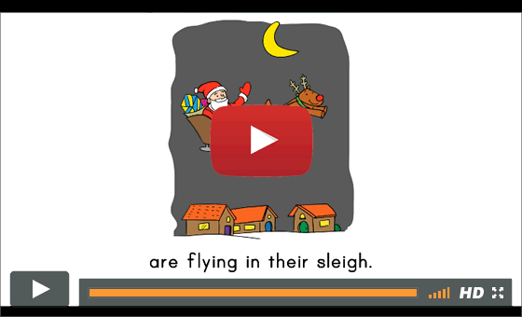
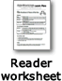
5. Do "Christmas Match Up" worksheet activity
Give all the students the worksheet and have them match up the items taught earlier in the lesson and in the carol. As they are working ask individual students questions (e.g. Who's this? What's this?, etc.).
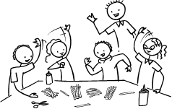6. Review colors:
We are going to make some paper chain decorations with different colors. Before class, cut out strips of different colored card to make the decorations. Show each color and elicit it ("What color is this?", "It's red"). Next, arrange students in groups around tables put a good pile of the strips on each table and tell the students to spread them out. Next play "Slam" - Teacher shouts out each color and students have to slam their hands down on the color.
7. Make "Paper Chain Decorations":
In groups have students use glue to create chains, as shown in the picture below:
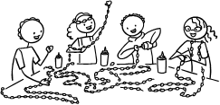
Give everyone about 5-10 minutes to make their chains. Finally, help your students decorate the classroom with the chains. If you can, keep these decorations in your classroom for the next lesson.
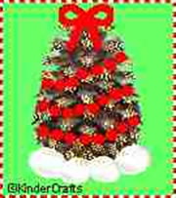8. Make "Pine Cone Christmas Trees"
You may be in an area where you can collect pine cones - if not they are usually quite easy to buy in arts and craft stores. All you need is pine cones (one per student), glitter, cotton balls, small beads threaded onto some cotton or dental floss and a star for the top.
To make the craft, have all the students follow these instructions:
1. Glue a few cotton balls to the bottom of the pine cone. These look like snow and help the "tree" stand upright.
2. Put a little dab of glue at the tips of the pine cone and then sprinkle on glitter.
3. String some small beads onto dental floss and then tie off the last bead with a knot. Wrap the beads around the pine cone and glue them to the tree.
4. Top off your tree with a small star, bow or other decoration.
.

Wrap Up:
1. Assign Homework: "Decorate the Christmas Tree"
2. Do your usual end of class routine (tidy up, put away things in their bags, sing "Goodbye song", etc).
3. As each student goes to the door to leave the classroom show them a flashcard and elicit the word (e.g. Santa). If they get the word right, they can leave. If wrong, they have to go to the back of the line and try again.

