Колина Светлана Павловна
Учитель иностранных языков
МБОУ СШ №41
«Авторские образовательные материалы для развития навыков устной речи/7 класс/УМК Форвард»
Тема“A letter from the USA”
- Условный диалог-расспрос. Asking direct questions, finding out the information.
You are in New York with your family. You would like to visit Statue of Liberty. Call and find out the following information:
- откуда отправляется паром на остров Свободы;
- ближайшая станция метро;
- стоимость билета на паром;
- стоимость посещения Статуи Свободы;
- можно ли посетить остров Эллис на пароме за одну экскурсию.
Use it:
1 From .where …..the ferry boat to the Liberty Island…….?
2……………the nearest underground?
3………….a ticket ……….. ?
4…………visiting of……….?
5. ……………..Ellis Island………?
- Монолог. Choosing and presenting the photo.
Imagine that these are photos from a weekly newspaper. Choose one photo to present to your friend. In your talk remember to speak about:
- where and when the photo was taken
- what/who is in the photo
- what is happening
You have to talk, starting with “I have chosen photo number …”
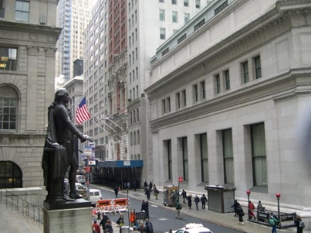
Use it:
Look! I would like to show this photo to you.
This photo …………………may be..…….
…………………….in the Bowling Green Square.
…………………………..….in the Wall Street.
Charging Bull/Washington’s monument…………...
It is………………….right now.
By the way, the atmosphere of this photo is…
I can add……………………
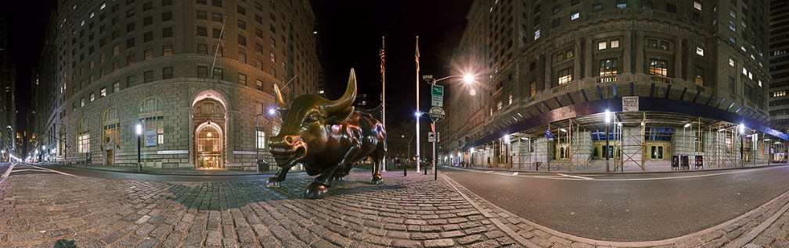
3. Монолог. Comparing and contrasting the photos.
Compare these 2 photos. In your talk:
- give a description of them (action, location)
- say what they have in common
- in what way they are different
- say where you would like to be and why
Use it:
I would like to compare 2 pictures.
In the first …………….Madison Square Garden.
The action takes place……….
In the second picture there is……..
It is happening………………..… .
Both these photos have ………. in common.
There are also the differences between these pictures.
The most important difference is …….
Moreover, …………………………………….
I would like (to be in the first situation, to take part in the second action)
I prefer ……-ing.
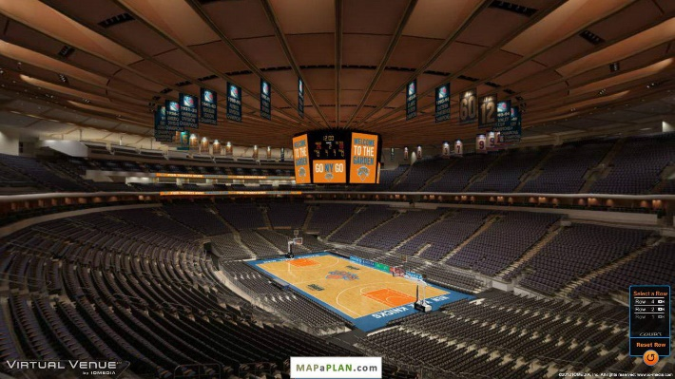
That is all I want to say about it.
4.Условный диалог-расспрос. Taking part in a telephone survey. Giving full answers to the questions.
Welcome to our competition “Sharks? Sharks!”. Answer the following questions correctly and quickly and you will get a prize.
Electronic assistant: Are there about 400 hundred different types of sharks in the world?
Pupil:__________________________
Electronic assistant: How long do the sharks live?
Pupil:____________________________________
Electronic assistant: Are they hunted by people?
Pupil:____________________________________
Electronic assistant: How many of them are killed every year?
Pupil:_____________________________________
Electronic assistant: Why should sharks be protected?
Pupil:______________________________________
Electronic assistant: How far can they hear?
Pupil:__________________________________________

5.Тематическое монологическое высказывание. Giving a talk .

Give a talk about writing letters.
Remember to say:
- about letters in the past;
- about today’s letters;
- whether you write letters.

I am going to give a talk about writing letters. To my mind, it is interesting to talk about it. We don’t write letters nowadays as our grannies did. My granny says that she wrote letters to her parents twice a month when she left them. She informed them all news and waited for a letter back from her parents. Time passed, things changed.
Today we write messages to our friends and relatives by the Internet. They are not so long, but we get answers very soon. Moreover, we can chat in Skype, that’s why it is not necessary to write. But there is something mysterious in writing paper letters.
To sum up, we can not stop the time and something is disappearing.
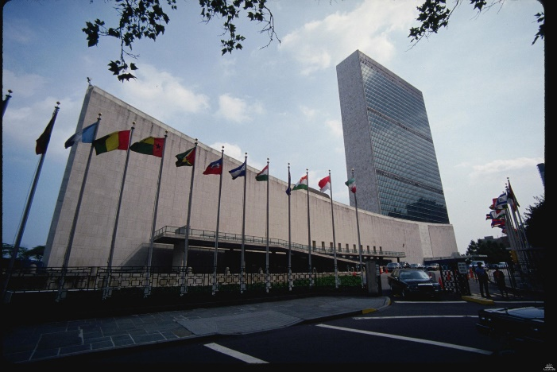
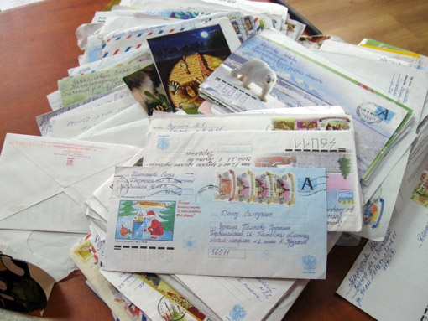
Тема“The world of English”
- Условный диалог-расспрос. Asking direct questions, finding out the information.
You’ve got a message from your friend who is on tour in London. He has visited Stonehenge. You are having a Skype conversation. Ask him:

- действительно ли это таинственное место;
- с какой целью это сооружение было построено;
- был ли он календарём;
- много ли туристов посещают эту достопримечательность Англии;
- стоит ли посетить это место;
Use it:
1. ……………….a mysterious place?
2. ………… the purpose of this…….?
3. ………………a calendar?
4. …………………………?
5. Is…..………….worth seeing?
- Монолог. Choosing and presenting the photo.
Imagine that these are photos from a magazine. Choose one photo to present to your classmate. In your talk remember to speak about:
- where and when the photo was taken
- what is in the photo
- what is happening
You have to talk, starting with “I have chosen photo number …”
Use it:
Look! I would like to show this photo to you.
This photo was taken……………...
It was……………………………..
(What?)…………… in this picture.
There are………………………….in a distance.
There are…………..in front of the building.
We can see………………..as on the map.
By the way, the atmosphere of this photo is….
3. Монолог. Comparing and contrasting the photos.
Compare these pictures. In your talk:
- give a description of them (action, location)
- say what they have in common
- in what way they are different
- say where you would like to be and why
Use it:
I would like to compare 2 pictures.
In the first picture we can see …...
The action takes place……….
In the second picture there is ……..
It is happening…… .
Both these photos have ………. in common.
There are also the differences between these pictures.
The most important difference is …….
Moreover,
I would like (to be in the first situation, to take part in the second action)
I prefer ……-ing.
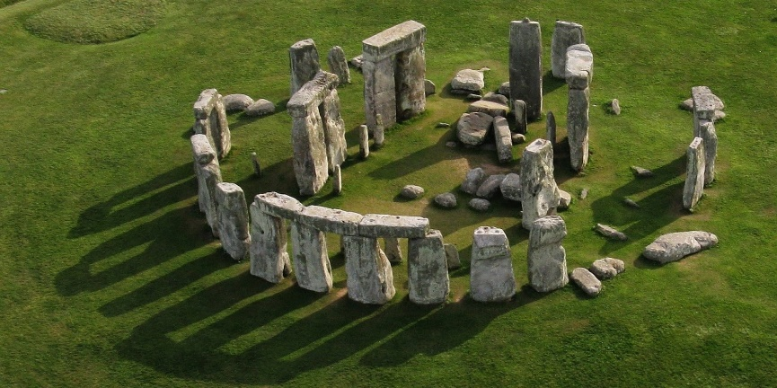
That is all I want to say about it.
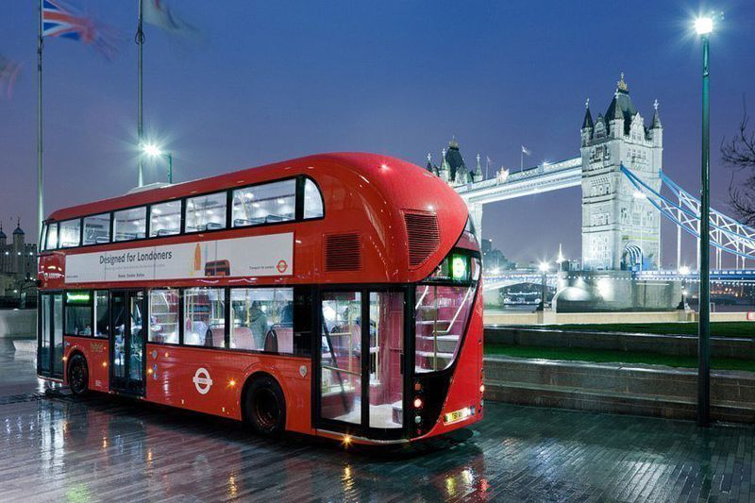
4.Условный диалог-расспрос. Taking part in a telephone survey. Giving full answers to the questions.
Welcome to our quiz “English-Speaking Countries”, call us and answer the questions. The winner will get a prize.
Electronic assistant: What is the official name of South Africa?
Pupil: (the Republic of South Africa)
Electronic assistant: What is the name of people in New Zealand?
Pupil:____________________________________
Electronic assistant: How many people speak English as the first language?
Pupil: (375 mil)________________________
Electronic assistant: Has it an official status in India?
Pupil:_____________________________________
Electronic assistant: What status does it have in Pakistan, in the Republic of the Philippines and Sri-Lanka?
Pupil: (semi-official)________________
Electronic assistant: What English is the language of?
Pupil:__________________________________________
Electronic assistant: How many people are believed to speak English as a foreign language?
Pupil: (750 mil)_________________________

5.Тематическое монологическое высказывание. Giving a talk .

Give a talk about learning foreign languages.
Remember to say:
- about advantages of knowing them;
- about the importance of the English language.
I am going to give a talk about learning foreign languages and especially English. To my mind, it is interesting to talk about it. To my mind, knowing of foreign languages gives us a lot of pluses and advantages.
Firstly, it helps us to communicate with people from other countries in the Internet and make new friends. You can travel all over the world and communicate with local people without any problems. Secondly, it is easier to find a job abroad. Thirdly, knowing of a foreign language is fun in our daily life. For example, when you listen to foreign songs, you can understand the meaning of them. If you know the language, you can watch the films in the original.
And at last, English has become a means of international communication. It is the language of science and technology, business and diplomacy, sports and music. That’s why I am sure that learning it is worth doing.

Тема“Describing personality”
- Условный диалог-расспрос. Asking direct questions, finding out the information.
You are the leader of the volunteer club. A girl of 14 wants to join it. Find out the following information:
- каковы её лучшие качества;
- какие плохие качества характера;
- организованный ли она человек;
- обладает ли достаточной энергией и энтузиазмом;
- проявляет ли заботу о старшем поколении;
Use it:
1. What are ………………qualities?
2. …………………… ……………?
3. ………..an organized…………?
4. Do……………..a lot of energy and enthusiasm?
5. ……………….care about ………generation?

- Монолог. Choosing and presenting the photo.
Imagine that these are photos from magazines. Choose one photo to present to your friend. In your talk remember to speak about:
- where and when the photo was taken
- what/who is in the photo
- what is happening
You have to talk, starting with “I have chosen photo number …”
Use it:
Look! I would like to show this photo to you.
This photo was taken………………………….
(Who?)…….is/are in this picture.
It is a famous……………….all over the world/country..
Moreover, she/he………………………(a talk show host).
(Present Progressive) They are/He is……….right now.
By the way, the atmosphere of this photo is….(calm, merry, work)
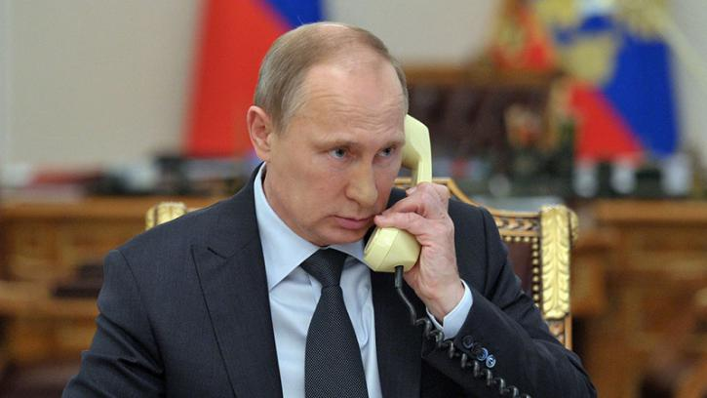
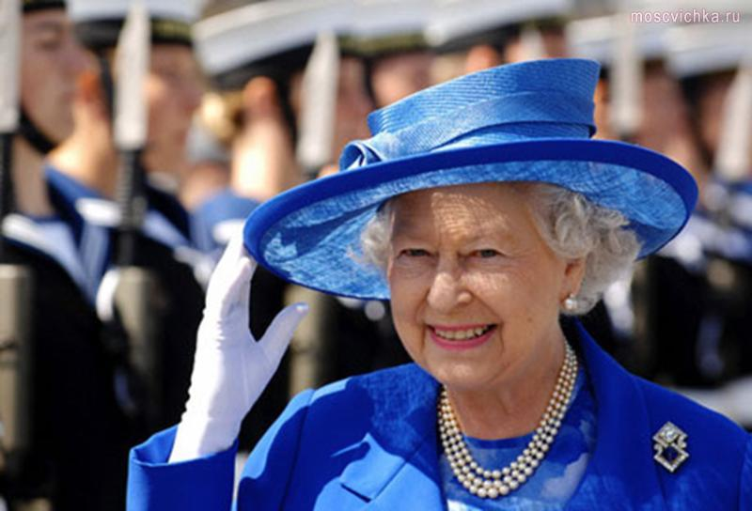
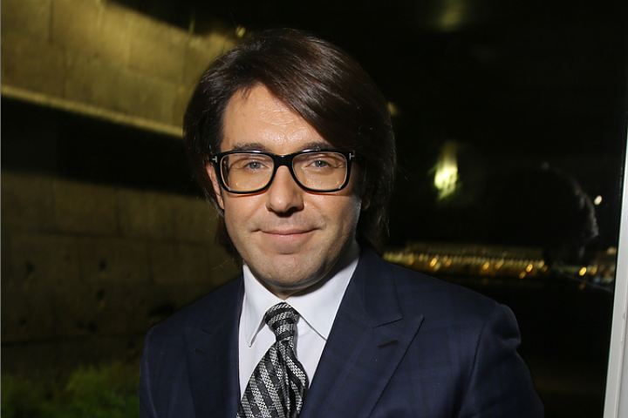
Монолог. Comparing and contrasting the photos.
Compare these 2 photos. In your talk:
- give a description of them (action, location)
- say what they have in common
- in what way they are different
- say where you would like to be and why
Use it:
I would like to compare 2 pictures.
In the first picture we can see …...
The action takes place……….
In the second picture there is /there are……..
In my opinion it is happening…… .
Both these photos have ………. in common.
There are also the differences between these pictures.
The most important difference is …….
Moreover, the…….is/are…. –ing, and the…….is/are…..-ing).
I would like (to be in the first situation, to take part in the second action)
I prefer ……-ing to……………..
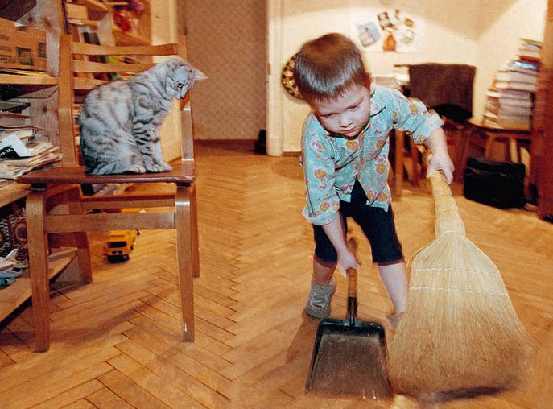
That is all I want to say about it.
4.Условный диалог-расспрос. Taking part in a telephone survey. Giving full answers to the questions.
If you are going to take part in a competition “Ideal Person”, answer the following questions, please.
Electronic assistant: Do you have good manners?
Pupil:__________________________
Electronic assistant: Are you always ready to help?
Pupil:____________________________________
Electronic assistant: Do you worry without good reason?
Pupil:____________________________________
Electronic assistant: Are you good at planning and arranging things?
Pupil:_____________________________________
Electronic assistant: You are easy-going, are not you?
Pupil:______________________________________
5.Тематическое монологическое высказывание. Giving a talk .

Give a talk about friend’s personality.
Remember to say:
- about your best friend;
- about friendship in our life;
I am going to give a talk about my friend. To my mind, it is interesting to talk about it. Every person has friends. So do I. would like to tell a few words about my best friend. She is 13. I’ve known her for 3 years. I like her for her personality. She is funny, I never get bored with her. She is clever, kind and generous. We always talk to each other about our problems.
Best friends understand and support each other. Sometimes it is really hard to find a right decision in different situations. Friends help here.
To sum up, friendship, as love, is a complicated thing. But a real friend is a treasure and we should not forget about it.

Тема“How good a friend are you”
- Условный диалог-расспрос. Asking direct questions, finding out the information.
-Interview your partner. Find out the following information:
- где он жил, когда пошёл в школу;
- когда он закончит школу;
- сколько лет изучает английский язык;
- работал ли когда-либо с маленькими детьми;
- где бы хотел поработать: в Англии, Шотландии или Уэльсе;
Use it:
1. ……..were………..ing……………..started………?
2. ……………………….. ?
3. ………………………..?
4. …………..ever…………………….before?
5. …………would………………….?
- Монолог. Choosing and presenting the photo.
Imagine that these are photos from one of the magazines. Choose one photo to present to your friend. In your talk remember to speak about:
- where and when the photo was taken
- what/who is in the photo
- what is happening
You have to talk, starting with “I have chosen photo number …”
Use it:
Look! I would like to show this photo to you.
This photo…………..……………………..
(Who?)…….is/are in this picture.
The boy/the man……greedy/angry, because……………….
They…………….quarrel to…………
He……always…………in such situations.
They are/He is……….right now.
By the way, the atmosphere of this photo is….(unpleasant, typical for…..)
3. Монолог. Comparing and contrasting the photos.
Compare these 2 photos. In your talk:
- give a description of them (action, location)
- say what they have in common
- in what way they are different
- say where you would like to be and why
Use it:
I would like to compare 2 pictures.
In the first picture we can see …...
The action takes place……….
In the second picture there is /there are……..
In my opinion it is happening…… .
Both these photos have ………. in common.
There are also the differences between these pictures.
The most important difference is …….
Moreover, ……………………………..easy-going/lazy.
I would not like (to be in the first situation, to take part in the second action)
I don’ t prefer ……-ing.
4.Условный диалог-расспрос. Taking part in a telephone survey. Giving full answers to the questions.
Would you like to take part in our “Personality Quiz”? Then, answer the following questions, please.
Electronic assistant: Do you always tell your best friend about your problems?
Pupil:__________________________
Electronic assistant: How often do you see each other?
Pupil:____________________________________
Electronic assistant: Do you quarrel sometimes?
Pupil:____________________________________
Electronic assistant: Do you ever criticize your best friend?
Pupil:_____________________________________
Electronic assistant: How do you find your behavior?
Pupil:______________________________________
5.Тематическое монологическое высказывание. Giving a talk .

Give a talk about yourself.
Remember to say:
- about your character;
- what is good and bad in it;
- about your plans in working at yourself.
I am going to give a talk about myself. Maybe it is not modest but…..
I am already 13 and I have got definite traits of character. My memory is not bad, it helps me in my study. They say I am clever.
Well, I think I am helpful. There were many occasions in my life when I really wanted to help and helped different people. I would say I am a bit hurried. It is not well. My mum often tells me not to be in a hurry. I love my close relatives and remember their dates of birth. It would great to become a healthy, easy-going and organized person.
I want my parents will be proud of

