**Учебный предмет:** английский язык.

**Учитель:**Узунян Наталья Николаевна

**Класс:** 5 класс

**Авторы УМК:** «**Английский в фокусе» 5 класс, Ваулина Ю.Е., Дули Дж., Подоляко О.Е., Эванс В.**

**Тема урока: «Выходные»**

**Тип урока:** урок закрепления и обобщения знаний с элементами рефлексии

**Цель урока:** активизировать материал по теме «Выходные»

**Задачи урока:**

Практические:

1.Совершенствование речевых навыков;

2.развитие умений говорения (делать сообщение по заданной теме, описывать свои повседневные дела);

3.развитие умений читать с разными стратегиями (выделение главных и второстепенных фактов, формирование детального понимания прочитанного с целью дальнейшего использования полученной информации);

4. расширение лексического запаса.

Воспитательные:

1.Способствовать формировании позитивного отношения к иностранному языку, к культуре англо-говорящих стран, формировать позитивное отношение к собеседнику;

2. воспитание убежденности в приоритетности общечеловеческих ценностей;

3. воспитание потребности к творчеству.

Познавательные:

1. Раскрытие понятия «выходные»;

2. формирование произносительных и речевых навыков;

3. систематизация умений поискового и ознакомительного чтения.

**Оборудование:** рабочие листы, учебник, аудиозапись, презентация.

**Структура урока (45 мин.):**

1. Организационный момент

1. Приветствие (1 мин.)

2. Речевая зарядка (2 мин.)

3. Фонетическая разминка (5 мин.)

1. Вхождение в тему урока (2 мин.)
2. Основная часть урока

1.Повторение грамматического материала (3 мин.)

2.Физкультминутка (1 мин.)

3.Аудирование (6 мин.)

4.Проверка домашнего задания (10 мин.)

5.Игра (6 мин.)

1. Заключительный этап

1.Подведение итогов (3 мин.)

2. Домашнее задание (2 мин.)

3.Рефлексия (4 мин.)

**Содержание урока**

1. Организационный момент

1. Приветствие

- Good morning, children! I`m glad to see you!

- Good morning!

- Sit down, please!

- Let`s start our lesson. Answer my question:

1) Who is on duty today? (I am)

2) What is the date today? (Today is __________)

3) What day of week is it today? (Today is ___________)

4) What is the weather like today? (The weather is ______)

- Thank you. Sit down, please.

2. Речевая зарядка

- Let`s talk about your daily routine. Answer my question, please:

1) What do you usually do during the day? (I brush my teeth/wash my face/have breakfast/have lunch/do my homework/go to bed)

- So you can do so many different activities during the day.

3. Фонетическая разминка

- Now It`s time to warm up. Let`s read the poem. (приложение 1) Now read by heard, please.

- I want to tell you a little story. Last weekend there was a strong storm. It was so strong that it mixed the words. I need your help to gather words again. Take your activity sheets on your desk and match the words to form phrases. (Приложение 2) You have 1 minute to do the task.

- Check up yourself! Count the points.

- Let`s read the words!

4.Вхождение в тему урока

- Look at the blackboard, please. When do people usually do such activities? When do people rest, relax and they don`t work? Students don`t go to school? (Weekends).

- You`re right. So tell me, what is the theme of our lesson? (Weekends)

- Yes, the theme of our lesson is “Weekends”. But what are weekends? (Saturday and Sunday; When people don`t work; When students don`t go to school)

- What do you usually do at your weekends? (I visit my friends; I relax; I go shopping…)

- What are the people doing in the picture? (She is drinking coffee now; They are washing dog; She is writing email…)

1. Основная часть урока

1. Повторение грамматического материала.

- It`s time to do some grammar test. Take your activity sheets. You have 2 minutes to do the test! (Приложение 3)

- Exchange your activity sheets. Check up! Write down points.

2. Физкультминутка

- Let`s have a break and do some exercises.

**Stand up, sit down** (встаем, садимся)

**Clap, clap, clap.**(хлопаем в ладоши)

**Point to the window,** (показываем пальцем на окно)

**Point to the door,** (показываем пальцем на дверь)

**Point to the board,**  (показываем пальцем на доску)

**Point to the floor.**  (показываем пальцем на пол)

**Stand up, sit down** (встаем, садимся)

**Clap, clap, clap.** (хлопаем в ладоши)

3.Аудирование

- Open your books at page 80. Look at the letter. Who is this letter from? (Rosies).

Who is this letter to? (Linda)

What is Rosie doing? (She`s doing her homework)

What is Rosie`s mum doing? (She`s making some phone call)

What about her sister? (She`s playing with her friend)

- Let`s read the letter.

- Now the listening will be more clear for you. Take your activity sheets. (Приложение 4). Your task is to listen to the letter and choose the correct answer.

You have 4 minutes.

- Check up yourself. I hope you have done this test well.

4. Проверка домашнего задания

Let`s check how you did your homework. Open your exercise-books. Let`s check exercise ___.

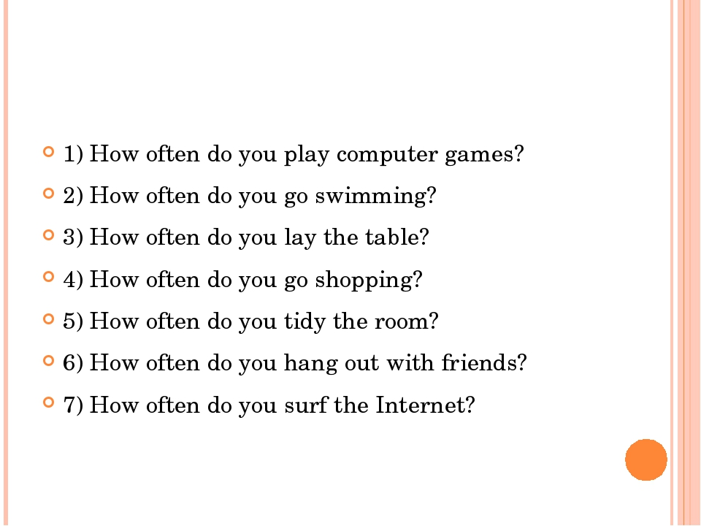

And now work in group! Make a sentence. (Students put words into sentences)

- Well done! Exercise ___.

1. Where does Greg live? — (B) — He lives in Arlington, Texas.

2. What’s his sister’s name? — (C) — His sister’s name is Emma.

3. What time does he wake up? — (D) — He wakes up at about half past six.

4. Does he have breakfast at home? — (A) — Yes, he does. He has breakfast at home.

5. 1What time does he leave home? — (F) — He leaves home at a quarter to seven.

6. Where does he have lunch? — (J) — He usually has lunch at the school canteen.

7. When does he return home? — (I) — He returns home at a quarter past five.

8. Does he do his homework at school or at home? — (E) — He does his homework at home.

9. Is he a helpful boy? — (H) — Yes, he is.

- And put the verbs in the correct box.

Ing: work, play, tell, drink, relax, sleep, try, look, walk, eat, cry, ski, begin, listen,

E+ing: come, take, make, serve, smile, prepare, shave,

Double consonant: swim, get, put, cut, hit, sit, travel, stop.

5.Игра

It`s time to play. You did homework well, let`s check how you deal with the game. The game is called “Conductor”. In Russian «Дирижер». I will be the conductor. I will show the card. Your task is to read the question all together. Then I will point to student and she or he will read out the sentence. And we say what is he or she doing.

Let`s try! Take your card.

-What are you doing?

- I`m playing basketball!

- She/He is playing basketball!

1. Заключительный этап

1.Подведение итогов

- So our lesson is coming to the end. Take your activity cards and Student`s Check Form (Приложение 5). Count the points. Look at the blackboard. It will help you.

2. Домашнее задание

- It`s time to write down your homework. Your homework is write a letter about your weekend ­.

3. Рефлексия

- Children, do you like our lesson today? (Yes, I do/No, I don`t)

- I will explain in Russia: на ваших столах лежат смайлики с «разным настроением». Зеленый смайлик означает enjoy – урок понравился, и то, что большинство заданий сделал правильно; желтый смайлик – like, урок понравился, также означает, что на уроке встретились трудности; красный смайлик – like, but very much, встретились трудности и совершил много ошибок. Повесьте, пожалуйста, ваши смайлики на доску.

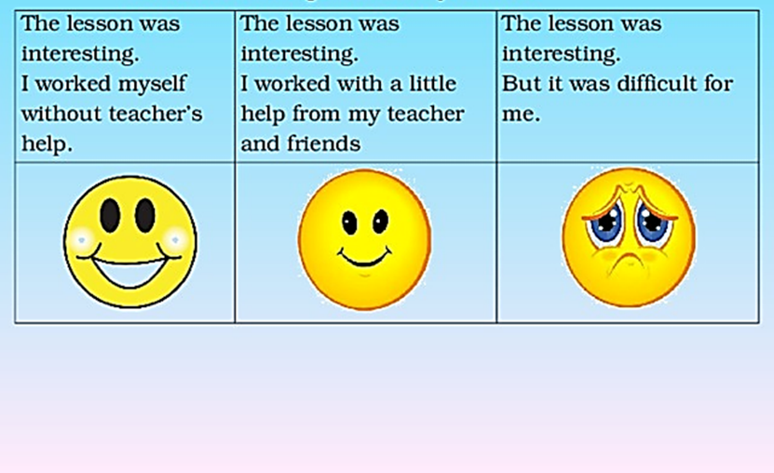 

- The lesson is over. Thank you for your working at the lesson! Have a good day. Good-bye!

**Приложение 1**

I check my watch⌚  
It's ten to eight  
I must get up  
Or I'll be late  
I stretch, I yawn,  
I scratch my head.  
Perhaps I'll just  
go back to bed! 🛌

**Приложение 2**

**Test 1**

**Match the words to form phrases.**

1. Write a. with a friend
2. Plant b. an email
3. Play c. in the garden
4. Make d. flowers
5. Work e. phone calls
6. Read f. books **Points**

**Приложение 3**

**Test 2**

**Choose the correct answer.**

**Present Simple**

|  |  |  |  |  |  |  |  |  |
| --- | --- | --- | --- | --- | --- | --- | --- | --- |
| 1 | I … with milk. | | | | | | | |
|  | a) | drink | b) | to drink | c) | | drinks | |
| 2 | My teacher … English well. | | | | | | | |
|  | a) | speaks | b) | to speak | c) | speak | | |
| 3 | His friend … in the forest. | | | | | | | |
|  | a) | live | b) | lives | c) | | | to live |
| 4 | Dogs like … meat and milk. | | | | | | | |
|  | a) | eat | b) | to eat | c) | | | eats |
| 5 | The farmer … coffee in the morning. | | | | | | | |
|  | a) | has | b) | have | c) | | | to have |

**Present Continuous**

1. Look! The children ____________________ .

a) is jumping b) jumping c) are jumping

1. The cat ___________________now.

a) are sleeping b) is sleeping c) am sleeping

1. My friend and I ____________________ now.

a) am not dancing b) are not danceing c) are not dancing

1. Dave ____________________________ now.

a) is reading b) reading c) am reading

1. Look! I ___ swimming.

a) am swimming b) am swiming c) is swimming

**Приложение 4**

**Test 3**

**Listening**

Choose the correct answer:

1. **What is Rosie doing?**
2. She is doing her homework. b. She is making some phone call.
3. **What is Tom doing?**
4. He is making some phone call. b. He is planting some flowers.
5. **What is Zoe doing?**
6. She is helping her father. b. She is playing with her friend.
7. **Where is Rosie`s mum?**
8. She is in the living room. b. She is the garden.
9. **Where is Rosie`s father?**
10. He is in the living room. b.He is in the garden.

**Приложение 5**

**Students` Check Form**

**Name: ________________________**

|  |  |  |
| --- | --- | --- |
| **Steps of the lesson** | **Points (max.)** | **My points** |
| 1. the beginning of the lesson | 1 1 |  |
| 2. speaking practice | 5 |  |
| 3. test 1 | 5 5 |  |
| 4. test 2 | 10 |  |
| 5. test 3 | 5 |  |
| 6.homework | 15 |  |
| 7.game | 3 |  |
| 8.the end of the lesson | 1 |  |
| **TOTAL AMOUNT** | **45** |  |

