Teacher: Neudakhina N.V.
Topic: Health and Body Care
Form: 5
Level: Low intermediate
Skills: Speaking
Reading
Language Focus: "Health and Body Care" vocabulary; modal verbs should, ought, must; the structures "You'd better…", "I've got to do smth"
Time: a lesson
Materials: a picture of a baby body, hand-outs, reading texts, pictures and tables, a cassette

Procedures:
I. Warming-up (2 min).
Greeting. Date.
T: Is anybody absent in your group (class) today? What's the matter with him/her?
LL (Language Learners): He/She is ill.
LL: Really? What a pity!
T: Isn't it a pity to be ill?
LL: Certainly it is.
 |  | stay in bed all day long.
 | you've got to
 |  | take bitter medicines.
If you are ill |  | go for a walk.
 | you can't
 |  | play with your friends.
Your friends ought to visit/call you.

T: And that's why I suggest you the discussion of some ways to be healthy and to keep fit.
LL: How very interesting!
That sounds great!
With great pleasure!

II. Phonetic drills (2 min).
Spring, spring, spring!
The trees are green,
Blue skies are seen.
Grey winter, go away!
The world looks new and gay.

Jack Sprat could eat no fat,
His wife could eat no lean;
And so between them both, you see,
They left the platter clean.
One man's breath is another man's death.
Good health is above wealth.

III. Pre-speaking activities (4 min).
1) What proverbs about health do you know?
Good health is above wealth.
An apple a day keeps the doctor away.
Early to bed, early to rise keeps a man healthy, wealthy and wise.
T asks LL to break the code and find out the problem about the topic of the lesson.
1 19 15 21 14 4 13 19 14 4 9 14 1 19 15 21 14 4 2 15 4 25
A s o u n d m i n d i n a s o u n d b o d y.
2) T brainstorms LL to name all the parts of the body (a picture of a baby body is on the blackboard).
3) T asks LL to name illnesses when some parts of the body hurt.
Head – headache, toothache, earache, backache, stomach-ache

IV. Reading and speaking.
Individual and pair work.
1) (6 min) T gives out hand-outs with conversations and asks LL to say whose medicines they were. LL work independently and compare their answers in pairs.
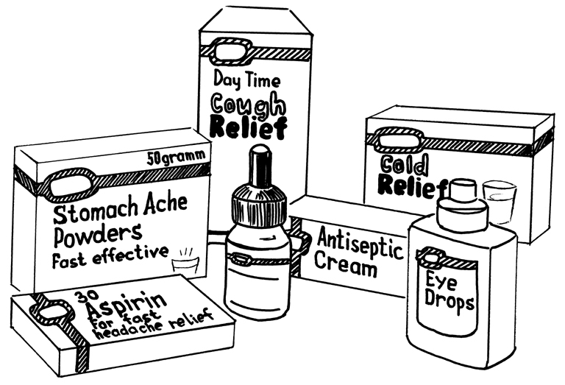

Example: This was Mandy's medicine. She had a headache.
Hi, Mandy. Why weren't you at the disco yesterday?
Oh, hi, Jane. I had a headache.

Good morning, Mrs. Hill.
Good morning. I'm sorry I wasn't at work last week.
Oh, that's all right. What was the matter?

I had a sore throat and a temperature.
Was it flu?
No, I don't think so. Just a cold. But I'm all right now.

What was the matter with you yesterday, Stuart?
My eyes were sore.
Yes, they're still a bit red.

Hello, Ben.
Hi, Jane. Hi, Tony. Why weren't you two at the swimming pool on Sunday?
We were ill. We had stomach ache. We think it was Jane's cooking.

You weren't at school last week, Rebecca. Were you ill?
Yes, Sir.
What was the matter?
I had a bad cough.
Are you all right now?
Yes, thank you.

2) (5 min) T gives out hand-outs and invites LL to discuss the problems connected with some illnesses and the piece of advice to find the decision.
T encourages LL to read the dialogues for checking up.
1. I keep getting the headaches.
2. I can’t get into my clothes.
3. I can’t sleep at night.
4. My eyes are often sore and I sneeze a lot.
5. I'm going to Kenya on business.
6. I’ve got a bad stomach.
7. I feel much better now, doctor.
8. I’ve got a terrible cough.
a. Good, you needn’t come back for a month.
b. You really must stop smoking.
c. Perhaps you should have an eye test.
d. You ought to do more exercises. It’s very relaxing.
e. You’ll have to have a few injections.
f. You shouldn’t eat so much fried food.
g. You really must lose some weight.
h. You should have some allergy tests.
3) (10 min) T asks LL to make up their own dialogues using the patterns above and CF.

V. Relaxation (2 min).
T: And now we've got to have some relaxation.
A song "Head and Shoulders"

VI. Reading. Post-reading tasks (7 min).
Group work.
1) T suggests LL to read the texts "My friend Lucy" and "Britney's advice to girls" and answer the questions after them.
Don't forget to use the proverbs.
My friend Lucy
My friend Lucy is fond of talking about health and diets. She is sure that a proper diet and exercise are both important for good health. As Lucy is not good at sports and doesn’t like to go in for running, swimming or skiing she prefers to keep to a diet. She has been on different diets since last year. First she tried the Japanese diet of rice, fish and vegetables, then Lucy decided to take no sugar with her drinks. She didn’t eat fried fish, meat or eggs. She took no butter, cream or sour cream. She ate a lot of cottage cheese and some other dairy products. But alas Lucy falls ill very easily and she permanently has colds.
Questions:
1. Diets don’t always help, do they?
2. What is important for good health?
3. What should you do to keep fit?
Britney’s advice to girls
Must girls look a certain way? I am sure you are most attractive when you are happy, active and full of energy. The secret is to be pleased with what you have. I think you should stop trying to be like other girls. Every person is unique. My friend kept to endless diets and always has a stomach-ache as a result. She doesn't go in for sports and never thinks of regular exercises. I can't say she is attractive. Do you really need a diet to look well? I prefer to eat a healthy diet and get a lot of exercise — when I’m travelling I do 1 hour 30 minutes of dancing.
Questions:
1. Does trying to be like other girls help to keep fit?
2. When are you most attractive?
3. What is Britney’s point of view on keeping fit?
2) LL discuss the picture "Victor's daily life". What does he do to keep fit?
3) Groups of LL introduce their "bad advice" (homework).
VII. Summing up (2 min).
Thus you have worked well today your marks are…
Hw: ex.7, p.238-240 (Review 2)

