Муниципальное бюджетное общеобразовательное учреждение «Средняя школа № 41» города Ульяновска имени генерал-лейтенанта А.Ф. Казанкина

Проект по английскому языку на тему: «Павел Третьяков и Генри Тейт. Неоценимый вклад в развитие русской и британской культур»

Учащиеся: Архипов Матвей, Данилов Михаил, Князев Никита, Фадина Александра (8Б класс)
Руководитель проекта: Колина Светлана Павловна, учитель иностранных языков высшей категории

Ульяновск 2023
Выбор темы с учётом практической значимости, в получении знаний о культурном наследии родной страны и страны изучаемого языка.
Тип проекта: информационно-исследовательский.
Цель: Знакомство с меценатами П.М.Третьяковым и Генри Тейтом.
Задачи:
- Формирование представления о Третьяковской галерее как первом музее русского искусства. Развитие мыслительно-речевой деятельности учащихся, умение обобщать, логически верно излагать свои мысли через активное сотрудничество в партнёрском общении;
- Развитие интереса учащихся к изобразительному искусству, ассоциативно-образного мышления, памяти, способности анализировать, сравнивать.
3. Воспитние чувства гордости за российскую художественную культуру; формирование эстетического восприятия произведений искусства.
4. Развитие обще - учебных, специальных коммуникативных умений и проектного мышления, интеллекта учащихся, их умения планировать и отслеживать последовательность выполняемых действий;
5. Развитие творческих способностей, самостоятельности, презентационных умений и навыков.
Методы:
- Определение проблемы, вытекающих из неё задач исследования;
- Выдвижение гипотезы их решения;
- Обсуждение методов исследования;
- Оформление конечных результатов;
- Анализ полученных данных, подведение итогов, корректировка, выводы.
Практический выход: защита, публикация в Интернете, выступление перед школьной аудиторией.

Содержание
- Всё начинается с истории. Развитие культуры невозможно без финансирования, а прогресс в искусстве без благотворительности.
- Благосостояние Павла Третьякова и Генри Тейта. Вклад в развитие искусства.
- Семья, труд, скромность, образование, успешный бизнес.
- Эрмитаж и первые полотна.
- Передвижники.
- Две лучшие картинные галереи мира.
- Похожие и разные. Единство в различии.

Pavel Tretyakov and Henry Tate. Invaluable contribution into the Russian and British cultures’ development.

No doubt, the life of our society is connected with culture, especially with art. The development of culture is impossible without funding and the progress in art without charity.
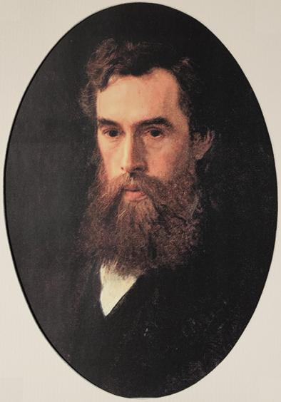
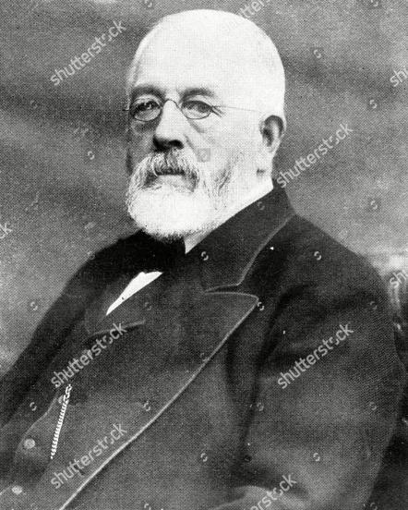
Russia and Great Britain are the countries whose cultural heritage is unique and valuable for the world community. Obviously, the culture of the countries could not have flourished without charity and the most famous representative of philanthropists in Russia is Pavel Mikhailovich Tretyakov and Sir Henry Tate in Britain.
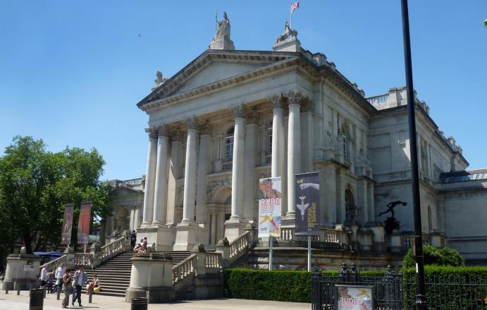
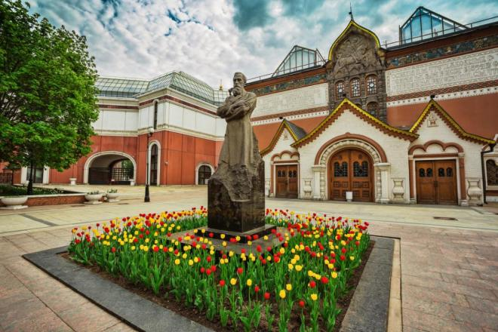
Both these personalities have greatly contributed to the development of the late 19th century’s art. They collected the most significant paintings and became the founders of the largest art galleries. Pavel M. Tretyakov founded the Tretyakov Gallery in Moscow, and Sir Henry Tate founded the British Tate Gallery in London. A great number of tourists visit these museums annually and try to do it again and again.
We’ll do our best to show their life path in comparison but together, because it is similar in many ways. Both of them were wealthy factory owners. They possessed a large sum of money and it did not make them greedy. Moreover, they spent a significant part of their capital on charity, in particular on the development of art.
Both Henry Tate and Pavel Tretyakov were brought up in patriarchal families. Henry Tate was the son of a priest, he spent his childhood in the provincial British town in severity and poverty. Pavel Mikhailovich Tretyakov came from a wealthy merchant family, however, he never interested in luxury. Hard work and discipline made them generous and unpretentious in everyday life. Pavel was the eldest in the family and responsible for all children. In his 15th he already helped his father in business together with his brother Sergey. After his father’s unexpected death young sons continued his business. They were brave and experienced and their business flourished in a very good way. Pavel got up at 6, drank coffee and went to his gallery to watch his pictures. It was necessary for him. He was a modest man and did not like a social life. He even was not at the opening of the gallery. Alexander III wanted to grant nobility to him but Pavel Mihailovich said: “ I was born as a merchant, I am going to die as it”
It goes without saying, education helped Pavel Tretyakov and Henry Tate to appreciate art and do a lot in business. Tate’s factories produced the best sugar in England, whereas the capital of Pavel Mikhailovich was 1 million 200 thousand rubles in 1891. The quality of products helped two industrialists multiply their wealth. The most important thing was not the amount of money spent, but the ability to invest it in a truly important matter.
Henry Tate and Pavel Tretyakov were ordinary manufacturers and there were many people like them in Russia and Great Britain at that time. They have no relation to the world of art but….
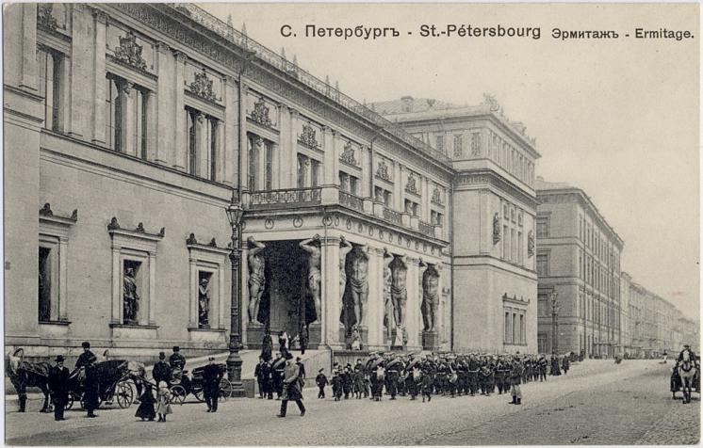
Tretyakov’s love for painting began in the 1850s after visiting the Hermitage. In the 1860s he started his collection of artworks. Firstly, he paid 900 rubles for nine canvases by Dutch masters, two years later he decided to collect artworks only by Russian artists. He said: “I consider the real painting which I am buying myself from the artist”. This man believed strongly in Russian artists’ works of art.
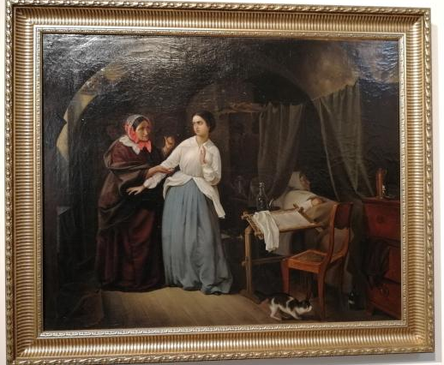
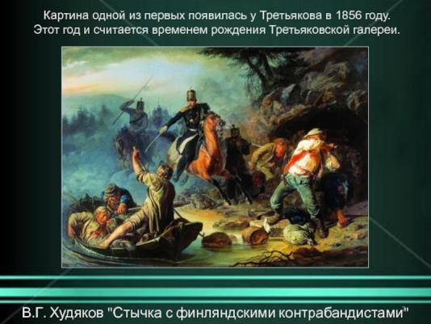
“Temptation” by A.N. Shilder and “Finnish smugglers” by V.G. Khudyakov were the first pictures in his gallery.

Henry Tate saw national art as an opportunity for state develop-ment, since art not only pleases the eye but also helps control public opinion. He began appreciating the works of art in the middle of the 19th century. In the 1850s he liked the works by the Pre-Raphaelite Brotherhood. They were artists who fought against the conventions of academic tradition. They always painted from nature and avoided religious matters in their art.Y. Hunt, D. Rossetti and Y. Waterhouse were among them, and their art was different. Tate started to buy their canvases. By doing so, he was able to support a new trend in art and make it more widely known and understood.
“The awakening Conscience”(1853)
“Proserpine”(1857)
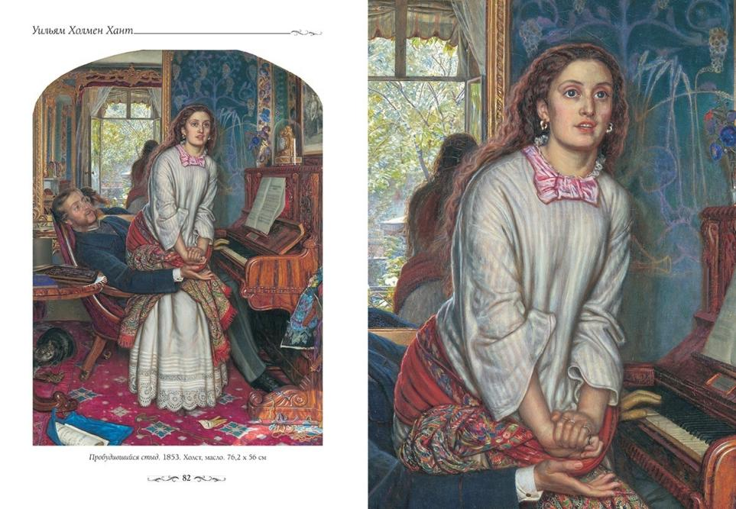

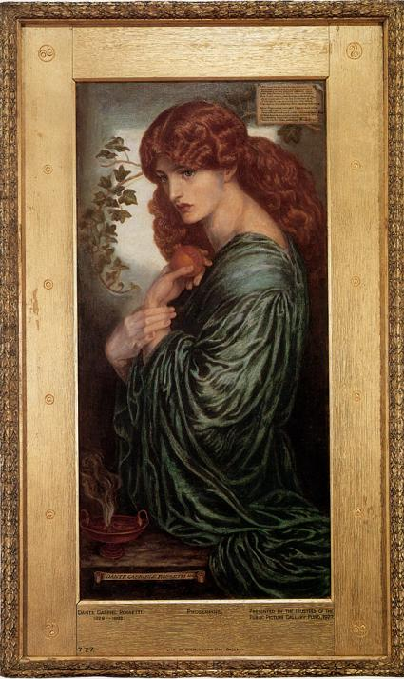
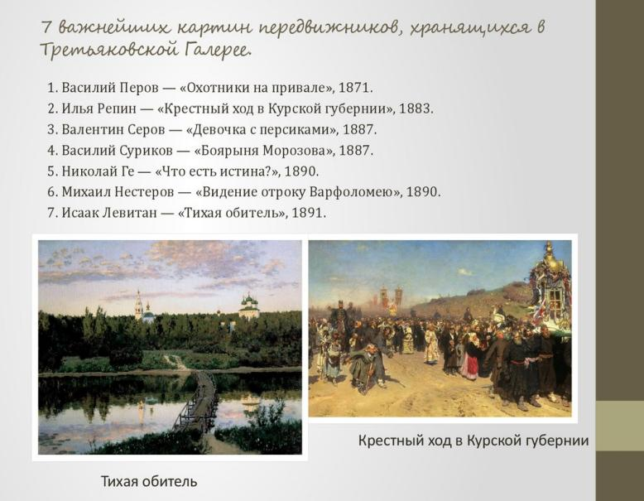
In 1863 Pavel Tretyakov supported the Peredvizhniki movement, who made art in the style of realism, such as Repin, Shishkin, Surikov and Polenov. Tretyakov bought their works, organized exhibitions and generally promoted the new form of art. Pavel Tretyakov listened to his heart while buying pictures. He told to the artists “ The puddle may be more beautiful than a nice peace of nature, only listen to your heart and give the poetry and truth”.
By the 1860s, Tretyakov’s and Tate’s collections were so vast that they had no room to put all their canvases. Pavel Tretyakov opened his own gallery and decided to donate the pictures to the city publicly. Tate wanted to donate 60 paintings to the British Gallery anonymously. Perhaps he was afraid of criticism since the Pre-Raphaelites’ art was not accepted by everyone.
The Tretyakov Gallery was opened to the public in 1867. The Tate Gallery in 1897.
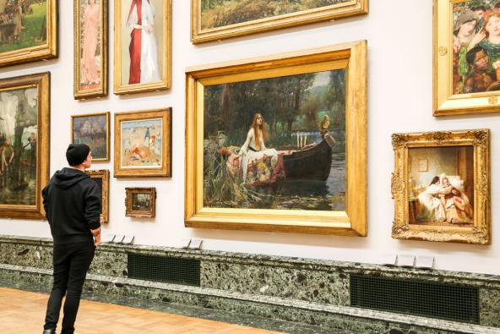
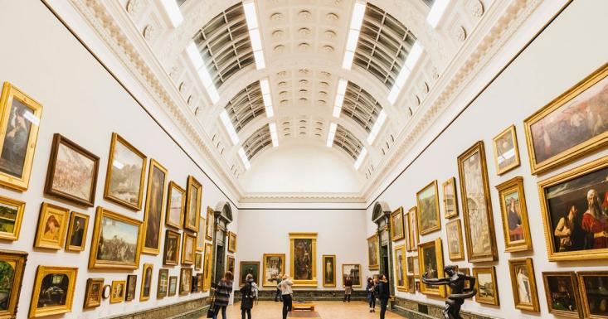
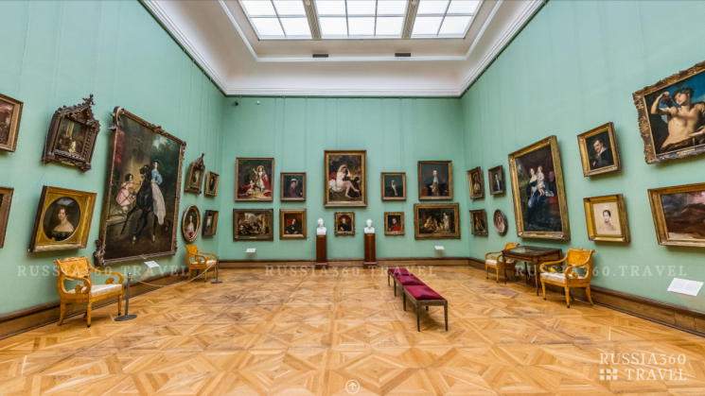
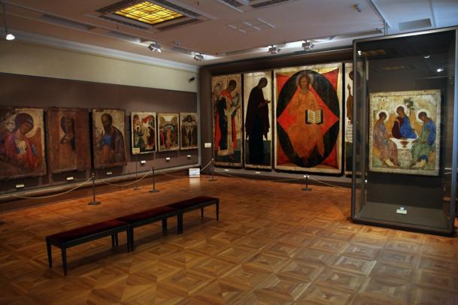
The appearance of both museums can be called the lifetime project for Pavel Tretyakov and Henry Tate. They really put their hearts into the galleries and did their best to establish them. They were sure that all paintings would stay with people whom they presented them.
Nowadays the galleries established by these people are the largest and best known in their countries. A unique collection of the Tretyakov Gallery includes the best works of Russian artists, and is visited by 2.5 million people every year. The Tate Britain possesses the world’s largest collection of British works of art.

Библиография:
Большая Советская Энциклопедия. Т. 43. – М.: Большая Советская Энциклопедия, 1956. – 670с., карты, илл.
В.Васнецов. Из собрания Государственной Третьяковской галереи / сост. В.А.Петров. – М.: Изобразительное искусство,1984.- 48с., илл.
Край Краснохолмский: Исследования краеведов. –Тверь: Тверской Печатный Двор, 2014 – 264с.
50 великих художников. Шедевры русской живописи. Вып. 1. Шишкин.- М.: DeAGOSTINI, 2010.- 31 с., илл.
50 великих художников. Шедевры русской живописи. Вып. 2. Айвазовский.- М.: DeAGOSTINI, 2010.- 31 с., илл.
50 великих художников. Шедевры русской живописи. Вып. 3. Васнецов.- М.: DeAGOSTINI, 2010.- 31 с., илл.
Пистунова А.М. Родник в лесу. Повесть о художнике И.И.Шишкине. – М.: Дет.лит., 1987. – 88с., илл.
Порудоминский В.И. Первая Третьяковка: Рассказы. – М.: Дет. лит., 1979. – 127с., илл.
Ф.Рокотов. Из собрания Государственной Третьяковской галереи / сост. В.А.Петров. – М.: Изобразительное искусство,1986.- 48с., илл.
А.Саврасов. Из собрания Государственной Третьяковской галереи / сост. В.А.Петров. – М.: Изобразительное искусство,1983.- 48с., илл.

