Date _____________ Name___________________
Test Paper № __ Variant 1
Unit 1. Me, my family and friends
1. Match questions and answers
- What's his name? | - She is eight.
- How old is she? | - I am from Spain.
- Where are you from? | - He is Sam.
- Are you good at English? | - Yes, I am.

2. Make a negative sentence.
Example: I am from England. - I am not from England.

1. I am lazy. - __________________________________
2. She is my sister. - _____________________________
3. He is late. - __________________________________

3. Make a sentences. Use "to be keen on".

4. Write about yourself. What's your name? Where are you from? How old are you? What do you like doing? What is your hobby?
___________________________________________________________________________________________________________________________________________________________________________________________________________________________________________________________________________________________________________________________________________________________________________________________________________________________________________________________________________________________________________________________________________________________

Date _____________ Name___________________
Test Paper № __ Variant 2
Unit 1. Me, my family and friends
1. Match questions and answers
- What's her name? | - He is seven.
- How old is he? | - I am from Ukraine.
- Where are you from? | - She is Marta
- Are you good at Maths? | - Yes, I am.

2. Make a negative sentence.
Example: I am from England. - I am not from England.

1. I am late. - __________________________________
2. She is ten. - _________________________________
3. He is from England. - __________________________

3. Make a sentences. Use "to be keen on".

4. Write about yourself. What's your name? Where are you from? How old are you? What do you like doing? What is your hobby?
___________________________________________________________________________________________________________________________________________________________________________________________________________________________________________________________________________________________________________________________________________________________________________________________________________________________________________________________________________________________________________________________________________________________

Date _____________ Name___________________
Test Paper № __ Variant 1
Unit 2. Sweet Home.

1. Match the pictures with the words
1. 2. 3. 4.

d. a secretary
c. a dancer
b. a doctor
a. a farmer

2. Find missing letters and match the words with the pictures
a b_t_r_ _m
a k_t_ _ en
a l_v_ng _oo_
a b_d_o_m
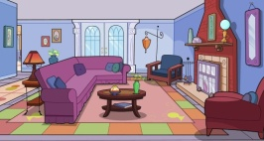
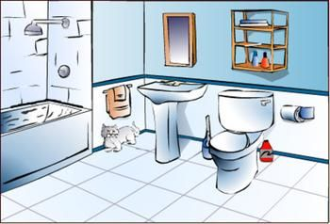
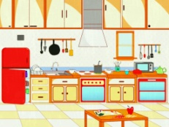
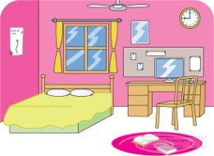

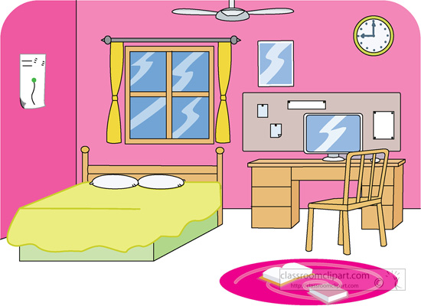
3. Answer the questions using AT, ABOVE, NEXT TO
- Where is a chair?
- Where is a window?
- Where is a table?
____________________________________________
____________________________________________
____________________________________________
____________________________________________
____________________________________________
____________________________________________

Date _____________ Name___________________
Test Paper № __ Variant 2
Unit 2. Sweet Home

1. Match the pictures with the words
1. 2. 3. 4.

d. a teacher
c. a singer
b. a doctor
a. a driver

2. Find missing letters and match the words with the pictures
a b_t_r_ _m
a k_t_ _ en
a l_v_ng _oo_
a b_d_o_m

3. Answer the questions using AT, ABOVE, NEXT TO
- Where is a TV set?
- Where is a picture?
- Where is a lamp?
____________________________________________
____________________________________________
____________________________________________
____________________________________________
____________________________________________
____________________________________________

Date _____________ Name___________________
Test Paper № __ Variant 1
Unit 3. School Time
1. Find missing letters
W_dn_s_ay
M_nd_y
S_n_d_y
F_id_y

b. Write the sentences with these words: I have got English on Tuesday.
- I ________________________ on ___________________
- They _____________________ on ___________________

- We ______________________ on ___________________
- I ________________________ on ___________________
2. What is your favourite lesson? Write a full answer using pictures.
1. ____________________________________________________________
2. ____________________________________________________________
3. ____________________________________________________________

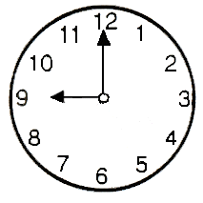
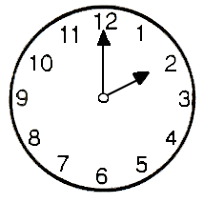
3. What time is it now?
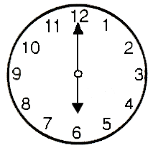

_______________ _______________ ________________
4. Write a letter filling the gaps
Friday, English, read, Tuesday, games
Hello Bill,
I am fine. My favourite days are ______________ and _____________. We have got ______________ on these days. English is my favourite lesson. We speak, ___________ and write English. We like singing English songs and playing _________ .
What lessons do you like?
Bye,
_____________

Date _____________ Name___________________
Test Paper № __ Variant 2
Unit 3. School Time
1. Find missing letters
T_ur_hd_y
T_e_da_
S_n_d_y
S_t_rd_y

b. Write the sentences with these words: I have got English on Tuesday.

- I ________________________ on ___________________
- They _____________________ on ___________________

- We ______________________ on ___________________

- I ________________________ on ___________________

2. What is your favourite lesson? Write a full answer using pictures.
1. ____________________________________________________________
2. ____________________________________________________________
3. ____________________________________________________________

3. What time is it now?

_______________ _______________ ________________
4. Write a letter filling the gaps
Friday, English, read, Tuesday, games
Hello Bill,
I am fine. My favourite days are ______________ and _____________. We have got ______________ on these days. English is my favourite lesson. We speak, ___________ and write English. We like singing English songs and playing _________ .
What lessons do you like?
Bye,
_____________

